

AMERICAN INTERNATIONAL UNIVERSITY–BANGLADESH (AIUB)
Dept. of Computer Science
Faculty of Science and Technology
CSC2210: OBJECT ORIENTED PROGRAMMING 2
Spring 2025-2026
Section: K12

Project Report On
Project Name: Doctor Schedule Management System

Supervised By
DR. MD. IFTEKHARUL MOBIN

Submitted By:
Name | ID
- Tamjid Muttaqi | 24-57591-2
Obtained Marks for CO2 and CO3 (Description given in the following page)
Assessment  Criteria | Not Attended/ Incorrect (0) |  | Inadequate  (1-2) |  | Average  (3) | Good  (4) | Excellent  (5)
Evaluation Criteria (CO2) |  | Total = |  | Evaluation Criteria (CO3) |  |  | Total =
Requirement fulfillment |  |  |  | Organization of the application
Validation |  |  |  | Representation and Integration of Database
Verification |  |  |  | Graphical User Interface

CO2: Display and verify the mean of a real-life Project using the concepts of C# Graphical User Interface based environment with database integration to depict a desktop-based application.
Assessment  Criteria | Not Attended/ Incorrect (0) | Inadequate  (1-2) |  | Average  (3) |  | Good  (4) |  | Excellent  (5)
Evaluation Criteria | Evaluation Definition
Requirement fulfillment | Fails to demonstrate any understanding of real-life scenario-based project development or functional requirement identification. There is no attempt to depict a project or identify functional requirements accurately. |  | Demonstrates limited understanding of real-life scenario-based project development and functional requirement identification. The project depicted lacks coherence or relevance to real-life scenarios, and functional requirements are inaccurately identified or insufficiently described. |  | Presents a basic depiction of a real-life scenario-based project and identifies some functional requirements. However, the project lacks depth or complexity, and some functional requirements may be vaguely defined or missing key details. |  | Effectively demonstrates a realistic scenario-based project and accurately identifies most functional requirements. The project is well-developed with appropriate complexity, and functional requirements are clearly articulated with relevant details. |  | Exhibits an exceptional understanding of real-life scenario-based project development and accurately identifies all functional requirements. The project is meticulously developed with thorough attention to detail, reflecting a comprehensive understanding of Object-Oriented Programming project development activities.
Validation | Fails to demonstrate any understanding or implementation of validation forms in their system. There is no attempt to deal with data validation, and validation requirements are completely ignored or incorrectly applied. |  | Demonstrates limited understanding of validation forms and data validation techniques. While some attempt may be made to implement validation, it is incomplete or poorly executed, leading to inadequate handling of data validation. |  | Shows a basic understanding of validation forms and data validation techniques. They attempt to implement validation, but some aspects may be missing or incorrectly implemented, resulting in partial or inconsistent handling of data validation. |  | Effectively demonstrates the use of validation forms and implements data validation techniques. Validation is mostly accurate and comprehensive, ensuring the proper handling of data input and verification in the system. |  | Exhibits an exceptional understanding and implementation of validation forms and data validation techniques. Validation is meticulously implemented with thorough attention to detail, ensuring robust data validation procedures and contributing to the overall reliability and integrity of the system.
Verification | Fails to demonstrate any attempt to verify the system data or functional requirements. There is no evidence of understanding or implementation of verification processes, and data flow is not considered. |  | Demonstrates limited understanding of verification processes and data flow in the system. Verification attempts are incomplete or inaccurate, and there is insufficient consideration given to ensuring data integrity and functionality. |  | Shows a basic understanding of verification processes and attempts to verify system data. However, verification efforts may be inconsistent or lack thoroughness, and there may be gaps in ensuring proper functional requirements and data flow. |  | Identifies and verifies system data, ensuring proper functional requirements are met. Verification efforts are mostly accurate and thorough, with attention to ensuring data integrity and appropriate data flow within the system. |  | Exhibits an exceptional understanding of verification processes and meticulously verifies system data. Verification efforts are comprehensive and precise, with a keen focus on ensuring all functional requirements are met and maintaining proper data flow throughout the system.

CO3: Prepare and Explain a real life desktop based application synthesizing several component of C# along with development tools to adhere the given requirements.
Assessment  Criteria | Not Attended/ Incorrect (0) | Inadequate  (1-2) |  | Average  (3) |  | Good  (4) |  | Excellent  (5)
Evaluation Criteria | Evaluation Definition
Organization of the application | Fails to identify any suitable real time application or requirements for project development activities related to OOP. |  | Limited understanding about the project scopes and scenarios or identification of functional requirements. |  | Lacks depth or relevance to OOP project development activities and may contain inaccuracies. Real-life scenarios are mentioned, but the discussion lacks depth or clarity. |  | Consider and integrate the idea of several core aspects of the project along with relevance to real-life scenarios. Demonstrating a solid understanding of the application presentation. |  | Generalize and exhibits an exceptional understanding of project preparation according to a to real-life scenarios. Also contains proper and insightful identification of the system which is comprehensive and precise.
Representation and Integration of Database | Fails to identify and present any understanding or implementation of database. Also failed to integrate the data with the project itself. |  | Limited understanding of the database concepts or their proper way of using in a real time project. While some attempt may be made to implement but it is incomplete or poorly executed, leading to inadequate design. |  | Lacks depth or relevance to database integration with the application. Shows a basic understanding but some aspects may be missing or incorrectly implemented, resulting in partial or inconsistency. May lack proper normalization. |  | Integrate the database with the forms properly and implements it with proper validation which is mostly accurate and comprehensive, ensuring the proper handling of data input and verification along with general normalization. |  | Exhibits an exceptional understanding and implementation of database ensuring attention to detail, and robust data manipulation procedures and contributing to the overall clarity.
Graphical User Interface | Fails to present or prepare GUI based application interfaces. There is no evidence of creating or integrating such things according to their usefulness. |  | Limited understanding of graphical user interfaces. Lack of design knowledge. Very poor attempt to make such things which are currently obsolete or can’t be identified as coherent. |  | Shows a basic understanding of creating user interfaces. Most of them are interconnected but maybe some of them lack it. However, most of it can be described as user friendly. |  | Effectively identifies and meet the consider the simplicity. Design related works are mostly accurate and taken proper attention to ensuring a user-friendly coherent system. |  | Exhibits an exceptional work design following a high standard of simple and elegant work. Several controls and mechanism has been organized in a preferred way according to the coherent usage .

Title : Doctor Schedule Management System

Chapter 1: Introduction
The Doctor Schedule Management System is a desktop-based application developed using C# Windows Forms. The system is designed to manage doctor schedules, patient appointments, user management, and payment processing efficiently.
In real-life scenarios, patients often face difficulties in finding available doctors, booking appointments, and handling payment procedures. This system aims to solve these problems by providing a structured platform where patients can view doctors, check their available schedules, book appointments, and complete payments with discount options.
The system supports multiple types of users such as Super Admin, Admin, and Patient (User). Each user has different access levels and functionalities. The system also includes CRUD operations, role-based access control, appointment management, payment system, discount coupons, and special case packages.

Chapter 2: Case Study
In a healthcare environment, managing doctor schedules, patient appointments, and payments manually is time-consuming and error-prone. Patients need a simple way to check doctor availability, book appointments, and complete payments with possible discounts.
This system allows patients to:
- View available doctors
- Check available days and time slots
- Book appointments
- Complete payment after booking
- Apply discount coupons or select special case packages
- Give reviews
Admins can:
- Add, update, and delete doctor information
- Manage doctor schedules
- Monitor appointments
- View payment history
Super Admin has higher control and can:
- Monitor public reviews
- Remove doctors based on poor feedback
- View all payment transactions
- Manage system-level operations
The system ensures that no duplicate appointments can be made for the same time slot and that payments are properly recorded, improving efficiency and reliability.

Chapter 3: User Stories
🔹 Super Admin:
- Can log in to the system
- Can view all doctors and users
- Can monitor public reviews
- Can remove doctors based on negative reviews
- Can view all payment transactions
🔹 Admin:
- Can log in to the system
- Can add, update, and delete doctor information
- Can manage doctor schedules
- Can view all appointments
- Can view payment history
🔹 User (Patient):
- Can register and log in
- Can view doctors
- Can check available schedule
- Can book appointment
- Can complete payment
- Can apply discount coupon or special package
- Can give review
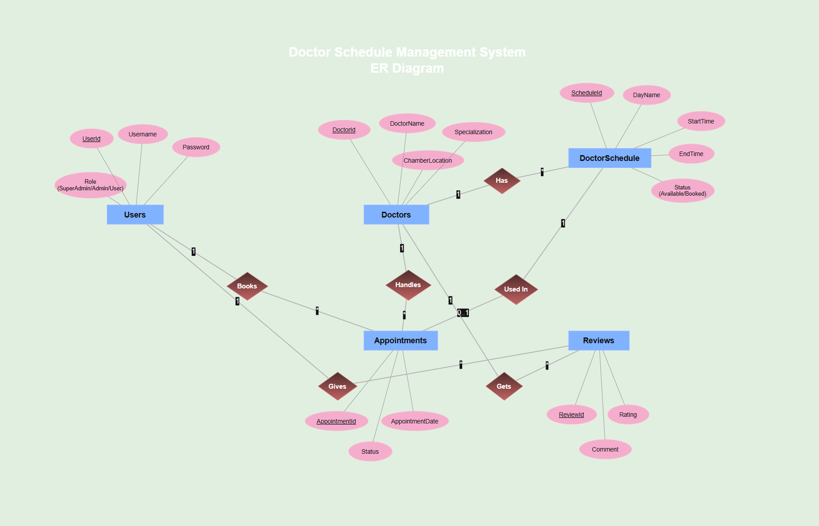
Chapter 4: ER Diagram

Chapter 5: Normalization & Finalization

🔹 Relationship: Doctor has Schedule (One to Many)
UNF:
DoctorName, Specialization, Day, Time, Status
1NF:
DoctorName, Specialization, Day, Time, Status
2NF:
- Doctor(DoctorId, DoctorName, Specialization)
- DoctorSchedule(ScheduleId, DoctorId (FK), Day, Time, Status)
3NF:
Same as 2NF

🔹 Relationship: User books Appointment
UNF:
UserName, DoctorName, Date, Time, Status
1NF:
UserName, DoctorName, Date, Time, Status
2NF:
- Users(UserId, Username, Password, Role)
- Appointments(AppointmentId, UserId (FK), DoctorId (FK), Date, Time, Status)
3NF:
Same as 2NF

🔹 Relationship: User gives Review
UNF:
UserName, DoctorName, Rating, Comment
1NF:
UserName, DoctorName, Rating, Comment
2NF:
- Users(UserId, Username)
- Reviews(ReviewId, UserId (FK), DoctorId (FK), Rating, Comment)
3NF:
Same as 2NF
🔹 Relationship: Appointment Payment System
UNF:
UserName, DoctorName, Amount, CouponCode, Discount, FinalAmount, PaymentMethod
1NF:
UserName, DoctorName, Amount, CouponCode, Discount, FinalAmount, PaymentMethod
2NF:
- Appointments(AppointmentId, UserId, DoctorId, Date, Status)
- Payments(PaymentId, AppointmentId (FK), Amount, CouponCode, DiscountAmount, FinalAmount, PaymentMethod, PaymentStatus)
3NF:
Same as 2NF
🔹 Relationship: Coupon / Special Package
UNF:
CouponCode, Description, DiscountPercent, CaseType
1NF:
CouponCode, Description, DiscountPercent, CaseType
2NF:
Coupons(CouponId, CouponCode, Description, DiscountPercent, CaseType)
3NF:
Same as 2NF

🔹 Final Tables (After Normalization)
- Users
- Doctors
- DoctorSchedule
- Appointments
- Reviews
- Payments
- Coupons

Chapter 6: Database Schema
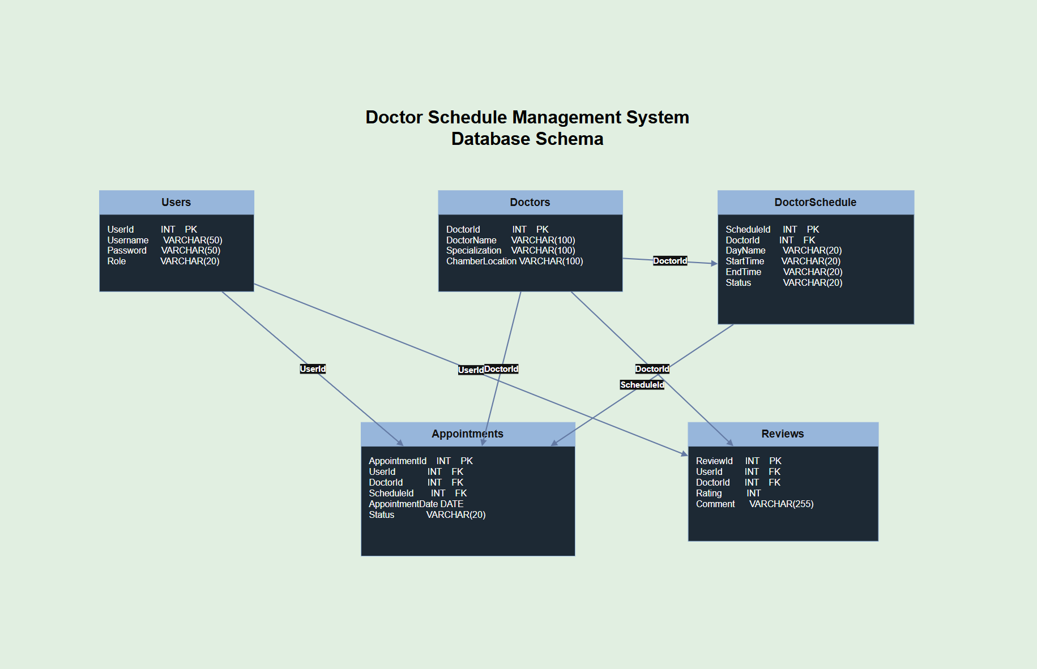

Chapter 7: Database Query

CREATE DATABASE DoctorScheduleDB;
USE DoctorScheduleDB;
CREATE TABLE Users (
UserId INT PRIMARY KEY IDENTITY(1,1),
Username VARCHAR(50),
Password VARCHAR(50),
Role VARCHAR(20)
);
CREATE TABLE Doctors (
DoctorId INT PRIMARY KEY IDENTITY(1,1),
DoctorName VARCHAR(100),
Specialization VARCHAR(100),
ChamberLocation VARCHAR(100)
);
CREATE TABLE DoctorSchedule (
ScheduleId INT PRIMARY KEY IDENTITY(1,1),
DoctorId INT,
DayName VARCHAR(20),
StartTime VARCHAR(20),
EndTime VARCHAR(20),
Status VARCHAR(20),
FOREIGN KEY (DoctorId) REFERENCES Doctors(DoctorId)
);
CREATE TABLE Appointments (
AppointmentId INT PRIMARY KEY IDENTITY(1,1),
UserId INT,
DoctorId INT,
ScheduleId INT,
AppointmentDate DATE,
Status VARCHAR(20),
FOREIGN KEY (UserId) REFERENCES Users(UserId),
FOREIGN KEY (DoctorId) REFERENCES Doctors(DoctorId),
FOREIGN KEY (ScheduleId) REFERENCES DoctorSchedule(ScheduleId)
);
CREATE TABLE Reviews (
ReviewId INT PRIMARY KEY IDENTITY(1,1),
UserId INT,
DoctorId INT,
Rating INT,
Comment VARCHAR(255),
FOREIGN KEY (UserId) REFERENCES Users(UserId),
FOREIGN KEY (DoctorId) REFERENCES Doctors(DoctorId));
CREATE TABLE Coupons (
CouponId INT PRIMARY KEY IDENTITY(1,1),
CouponCode VARCHAR(50),
Description VARCHAR(150),
DiscountPercent INT,
CaseType VARCHAR(100)
);
CREATE TABLE Payments (
PaymentId INT PRIMARY KEY IDENTITY(1,1),
AppointmentId INT,
Amount DECIMAL(10,2),
CouponCode VARCHAR(50),
CaseType VARCHAR(100),
DiscountAmount DECIMAL(10,2),
FinalAmount DECIMAL(10,2),
PaymentMethod VARCHAR(50),
PaymentStatus VARCHAR(20),
FOREIGN KEY (AppointmentId) REFERENCES Appointments(AppointmentId)
);

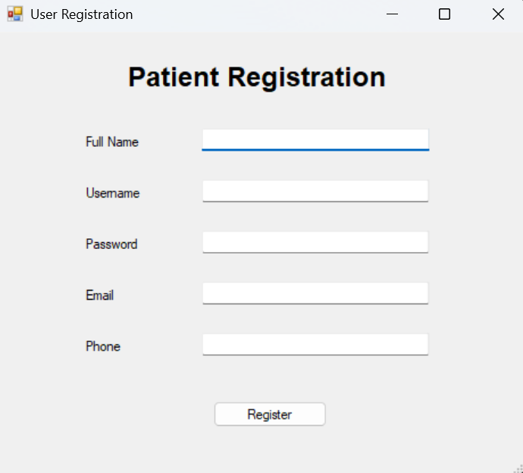
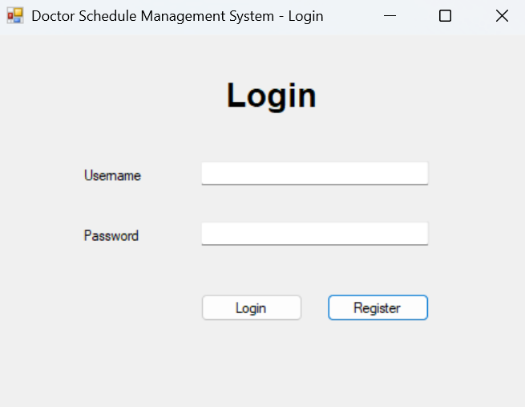
Chapter 8: Screenshot of Forms
